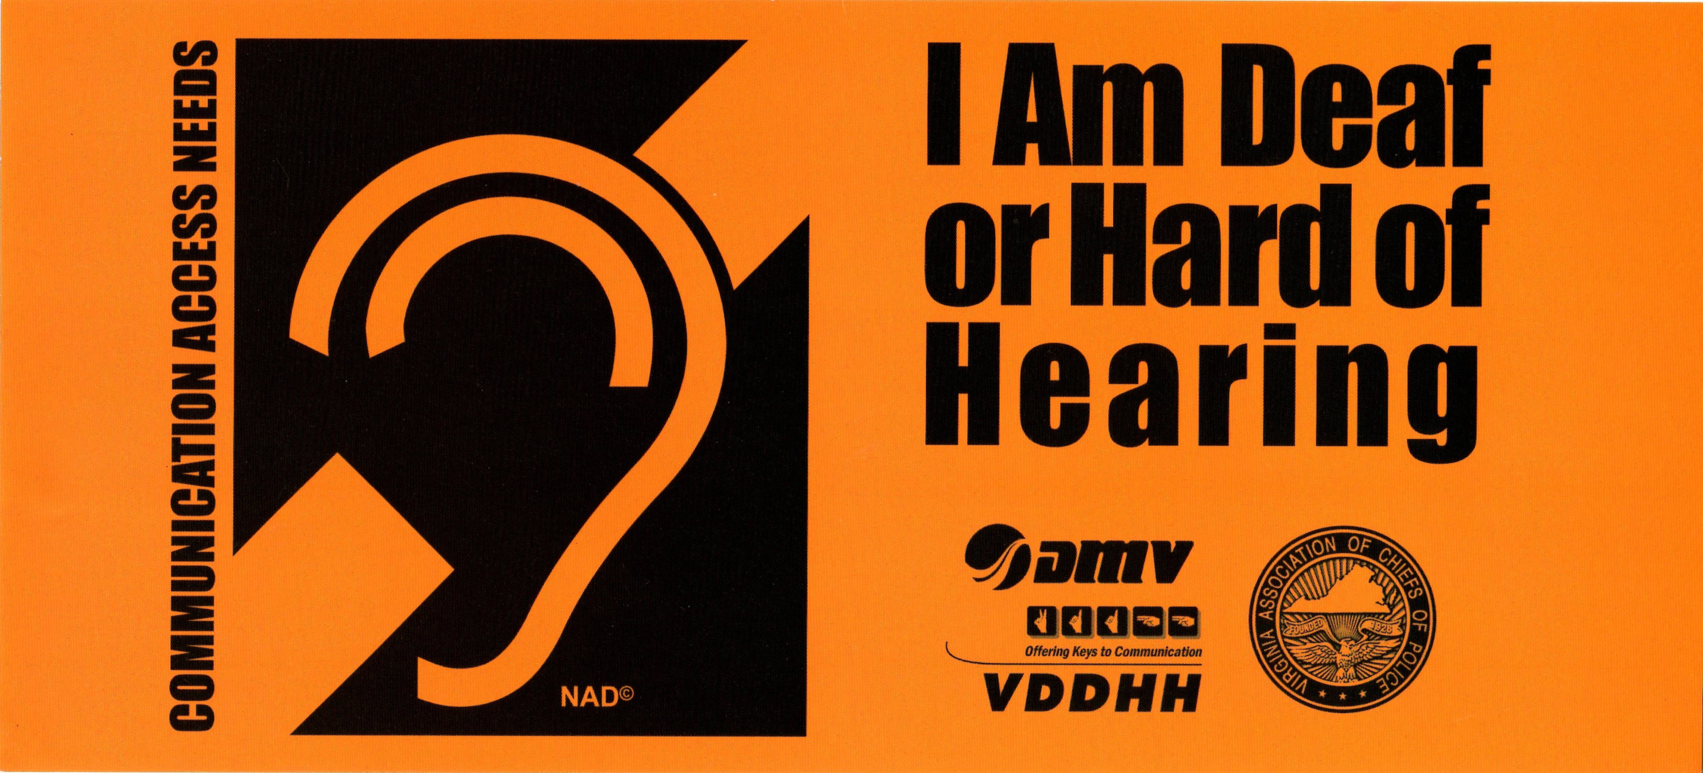

VISOR ALERT: A PROGRAM THAT WORKS!

The Visor Alert Program is a great example of how, working together, we can achieve meaningful change. This project is a joint effort between advocates, the Virginia Department for the Deaf and Hard of Hearing (VDDHH), the Department of Motor Vehicles (DMV) and the Virginia Association of the Chiefs of Police.

Although there are no solid numbers available, recent research estimates that between 1% - 2% of Americans are Deaf or Late-Deafened, and between 17%-22% of Americans are hard of hearing. That means that at least 800,000 Virginians experience some level of hearing loss. Many of these individuals will come in contact with police officers at some point in their lives. The safety of the officer and of the citizen is the reason behind the Visor Alert Card. The Card is designed to improve communication between the officers and the citizens.

Visor Alert cards and additional information about communication access are available from any VDDHH Outreach Specialist or from the VDDHH Central Office.



